§Towards understanding suction cup arrays

Million van den Berg  
BSc Molecular Life Sciences  
1001657

Table of contents

Introduction 2

Materials and Methods 4

Materials 4

Ecoflex surface preparation 4

Array 5

Single suction cup 5

Results 6

Surface 6

Array 6

Single suction cup 7

Discussion 9

Mean suction cup adhesion from array 9

Response difference 9

Increasing adhesion 9

Hertzian contact 9

Array failure 10

Conclusion 10

Bibliography 11

# Introduction

Probabilistic fasteners like Velcro are broadly used in products in daily life. The macroscopic behaviour of probabilistic fasteners is well-known: applying Velcro on shoes will keep them tied. Mechanical interlocking on the microscale gives adhesion on macroscale, in this case hooks that attach to loops. Adhesive surfaces are becoming ever more relevant by the rise of soft robotics. Soft robotics holds the opportunity to allow machines to perform mechanical work with deformable components. In recent work, artificial caterpillars mimic the biological movements of their natural counterparts, and artificial arms resemble muscle movements of an octopus [1]. Bio-inspired soft robots hold the opportunity to grab non symmetric and flat objects. Pneumatic or electric systems drive soft components that resemble limbs into the shape required by the application, such as a concentric contraction to allow gripping. Using less force than with conventional high-elastic modulus components enables gripping delicate objects such as fruits or eggs. Passive adhesion has proven useful in the design of soft grippers because a lower force is needed when the gripper surface is more adhesive [2].

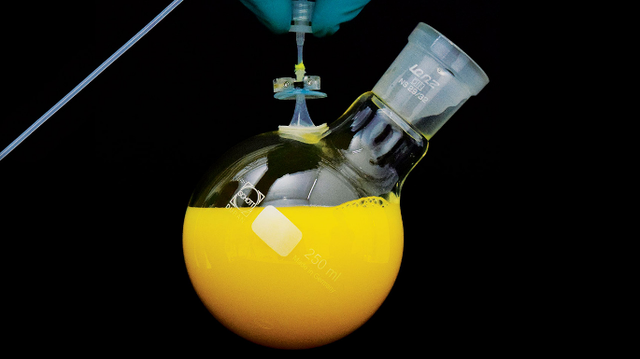

Figure 1: An image of a hygienic soft gripper series picking up food products (left image)[3]. A starfish gripper picking up a delicate product (right top) [4] and a gecko-inspired adhesive surface lifting a fluid containing flask (right bottom) [5].

For probabilistic fasteners there is one big challenge: predictability. Detachment of the features is not predictable due to their probabilistic nature. Each microscopic feature detachment could influence the adhesion. According to the Fibre Bundle Model (FBM) the passive adhesive surface will act like a chain with a weak linkage when the features are treated as FBM framework fibres [6]. Assuming that all microscopic features are equal and a fastener is only made of soft silicone, it could be prone to local load sharing upon detachment. [7]The weakest link will be the first adhesive feature to increase the probability of individual and array failure upon detachment. The neighbouring suction cups experience a force that was already upon them, adding to that is the force of a failed suction cup divided by the amount of direct neighbours [7]. Extra force upon the neighbouring suction cups could result in their detachment as well. Such a collaborative detachment event is often termed a "cascade" or "avalanche" [6]. When there is no local interaction between the features upon failure, the system should change to a global load sharing system. Since there are no neighbours to participate in local load sharing. Global load sharing is characterised by a scenario [7]where the force of a single failed feature will be divided over the all features in the system instead of the neighbouring features.

A shortcoming of the FBM is that the shape of the critical stress threshold is assumed. Before this theory could be applied to the array it is important to find out whether all the features in the array conform to this distribution. There would be an issue in modelling the adhesive properties of the array when non-equal distributions are found for individual features. Having an appropriate model will increase the understanding of array detachment which will hopefully lead to improving probabilistic fasteners. Adding to that, quantifying individual suction cups will also provide the possibility to compare different array features.

This thesis focuses on the adhesive properties of individual features that together make up a probabilistic fastening system. A setup is built to determine the strain and adhesion force for the individual features. Force-distance curves for 19 suction cups were measured, and their work of adhesion was quantified. The aggregate of force-distance curves for individual features offers to quantify the threshold stress distribution and compare it against array experiments, and provides an avenue to confirm the relevance of the FBM to probabilistic fasteners.

# Materials and Methods

## Materials

Dragonskin 30 (Dragonskin) and Ecoflex 00-30 (Ecoflex) were obtained from Smooth-On, perfluorodecyltrichlorosilane (PFTS), Norland Optical Adhesive NOA-61 was (UV curing glue) obtained from Edmund Optics.

## Ecoflex surface preparation

Surfaces were prepared as illustrated in Figure 2: First, we placed the 3D-printed surface in an empty petri dish, the Dragonskin was prepared by mixing the two components (1:1). Dragonskin was added to the petri dish after stirring thoroughly and degassing the mixture for approximately 10 minutes. A second round of degassing was performed after adding Dragonskin to the petri dish to allow trapped air bubbles to escape. Dragonskin was cured overnight. After curing, the 3D-printed surface was removed from the fresh mould, after which it was placed in a vacuum container in which an open sample bottle containing approximately 3 mL of PFTS was placed. The pressure was reduced to 9 mbar. For the third step, the mould was taken from the vacuum container. Ecoflex was prepared in a mixing cup (1:1), and the mould was filled with Ecoflex after thoroughly stirring. The filled mould was degassed again to allow escape of trapped air bubbles in the mould aided by a small spatula. After all bubbles were removed the sample was put in an oven at 50°C for 4 hours to cure the Ecoflex. Finally, the Ecoflex image was peeled out of the negative mould.

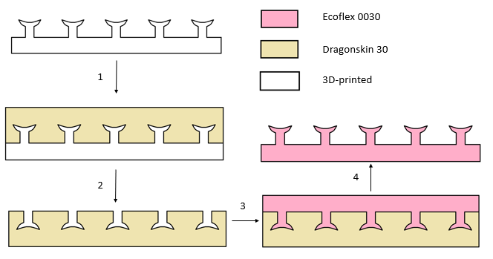

Figure 2 : Double-moulding procedure of a patterned surface, using a 3D-printer with clear resin, Dragonskin 30 for the first mould and Ecoflex 0030 for the final result using the following steps.   
1: Apply Dragonskin to the 3D-printed sample to obtain the first mould. 2: Remove the 3D-printed surface from the Dragonskin negative mould. A monolayer of perfluorodecyltrichlorosilane is applied to prevent sticking in the next steps. 3: Apply Ecoflex to the Dragonskin negative mould to obtain the Ecoflex sample. 4: Remove the sample from the Dragonskin mould.

## Array

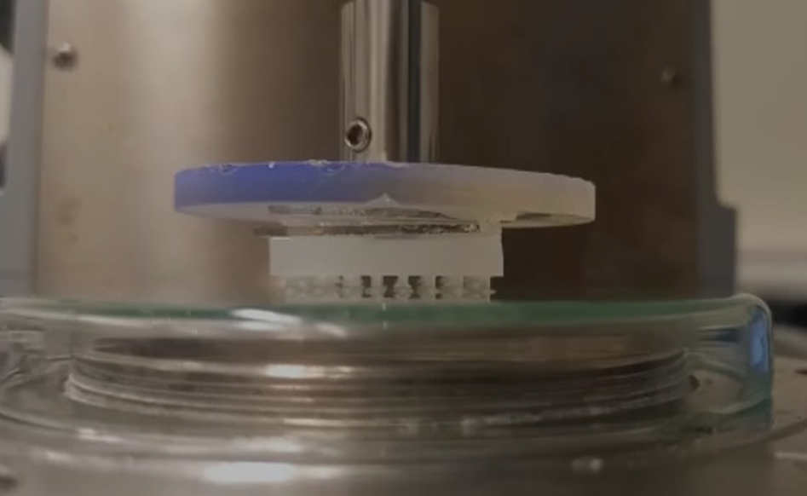An Anton Paar MCR-501 rheometer was used to test the adhesive property of the surface. Samples were attached to a glass background for alignment of the surface and the substrate. The glass and the Ecoflex surfaces were placed in a plasma oxidizer at the highest setting. The two parts were taken out of the machine after oxidizing for 40 seconds and stuck together. The sample was placed on the glass substrate resting on its suction cups. A large drop of UV glue was placed in the middle of the glass sample background. Now the rheometer rod with a 3D-printed disposable plate was lowered until the glue just touched the rod, forming a connection between the plate and the sample, after which the alignment was frozen in by curing the UV glue. The settings that were used in this experiment are: a preload of 3 N followed by a retraction step at a z-velocity of 500 μm/s. Quantities that were recorded by rheometer are gap size, time, force and the steps.

Figure 3: Fixing the suction cup array to the rheometer rod using UV curing glue.

## Single suction cup

An indentation setup was used to measure force-distance curves on a single suction cup. The setup was built according to Research Methods Soft Matter reader [8] using a Thorlabs breadboard, metal rods attached to a motor and a Futek LSB200 load cell. A schematical view is provided in Figure 4. The motor was attached to a spring operated platform, providing movement in the z-direction (vertical). A minor adjustment by Remco Fokkink to the setup caused the motor movement to be upward instead of downward to improve detachment data, detachment was now controlled by the motor instead of the platform spring. A small glass surface was attached to the moving stage. A preload of 50mN was applied to the suction cup. Followed by a retraction step at a z-velocity of 100 μm/s.

We performed the experiment approximately 180 times per day. Data was processed in MATLAB R2021b. Quantities that were recorded by the load cell and the motor are probe displacement, time, mass as well as force and the steps.

# Results

Figure 4: Schematic of the indentation setup used in the experiment.

## Surface

Probabilistic fasteners were prepared from Ecoflex by a two-step moulding procedure. Surfaces were designed in SolidWorks (2019), featuring a linear array with periodicity p = 4mm. The height of the features is 1mm and the diameter of the suction cup d = 2mm. Surfaces were printed using a Formlabs Form 3 3D printer with clear resin at the highest resolution in an angle of 30° in the y-direction to avoid the need for 3D-printing supports. The printed surface was double-moulded with Dragonskin 30 and a more flexible Ecoflex 0030 elastomer, which allowed to peel the surface from the mould without damaging features. (to the petri dish??)

## Array

Figure 5presents force-distance curves in approach and detachment of a glass surface moving against the previously described array of Ecoflex suction cups. Some variation in the measurements can be seen, this variation can be explained by the probabilistic nature of the order of suction cup detachment. There were detachment events in the experiment where single and/or multiple suction cups detached during retraction. We calculated the adhesion work Wadh using the following formula:

$W_{adh}=\int{\left(f-f_{baseline}\right)dε}$ where $dε=d- d_{full-contact}$

The mean was calculated for all measurements, this results in a mean of Wadh, mean = 1.586 N*mm and Wadh, single, mean = 37.76 N∙mm. Due to the difference in detachments of the suction cups it is important to compare the single suction cups to find an explanation for this variation.

Figure 5: Data obtained from rheometer measurements on an array of suction cups.

## Single suction cup

Figure 7 was obtained from single suction cup data, it is visible that approaches in the measurements are all alike. Measurement variation is seen in the detachments. Suction cups do not detach in the same manner throughout the experiments. The slope of the detaching curves before the adhesive area is steeper. Colors of the individual lines indicate which measurement the line is showing. Blue lines are earlier measurements than the yellow lines.

Individual suction cup measurements for all suction cups were plotted against time to check whether there was a certain drift or experimental issue that would be time related (Figure 6). Data was normalized to correct for baseline drift in the force signal. Considering a strong time dependence in Figure 6 shows it was decided that the data that would be used would be data from a plateau. (please mention why: you can say that we ignore the initial transient of the first 5 rounds and ignore the late time evolution after step 35)

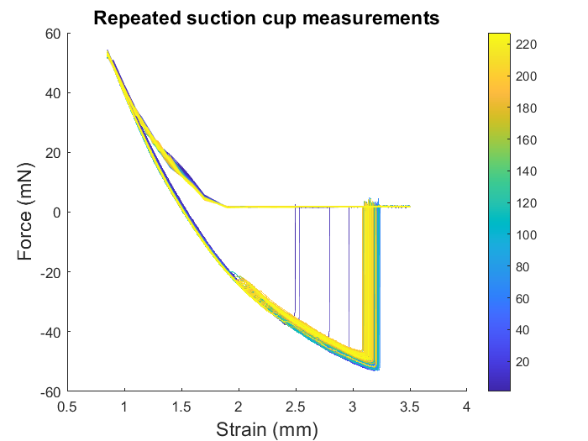

Figure 6: Suction cup adhesive work plotted against time.

Figure 7: Data provided by repeating the experiment on suction cup 6C 240 times.

For all the individual cups it was found that measurements 6-36 were the best possibility to have at least 30 measurements. In Figure 9 the measurements are plotted against time, still a small drift remains visible in the data but it is manageable. After determining that this interval was the best interval to calculate the means of Wadh in the same manner as used in previous section. In Figure 10 black dots with corresponding error bars represent means for the individual suction cups that were found in this experiment. A small smear is seen due to time dependency in the data.

A heatmap (Figure 8) was used to check for a relation between the mean adhesive work and the position in the array. The shown grid is a schematic view of the suction cup array and the axis provide the coordinates that are corresponding to the suction cups. This heatmap could show a spatial relation. However, Figure 8 does not show that the mean adhesive work is related to grid position.



Figure 8: A heatmap giving a visual representation of the mean suction cup adhesive work related to the coordinates in the array.

Figure 9: Suction cup measurements 6-36 plotted against time.

Figure 10: The calculated mean and error for suction cup measurements 6-36 in the following order: 1B, 1C, 1D, 2B, 2C, 2D, 3B, 3C, 3D, 3E, 4B, 4C, 4D, 5B, 5C, 5D, 6B, 6C, 6D.

# Discussion

## Mean suction cup adhesion from array

A simple estimate for the mean of Wadh, single would be:

$$W_{adh, single} = \frac{W_{adh, array}}{N_{suction cups}}$$

However, there is quite an observable spread in the plot with the suction cup means (Figure 10). The problem with this estimate is that there is a difference in preload for the experiments. The single suction cups were compressed into the background matrix when

$$F_{preload, single} = \frac{F_{preload, array}}{N_{suction cups}}$$

was applied, indicating that there are more factors to the relation between preload and adhesion. It could be caused by compression of the entire system versus compressing the area around a single suction cup. It is not realistic to relate the mean of Wadh, single to Wadh, array.

## Response difference

A simple expectation for all experiments was that the approach and detachment curves for the suction cups would be similar. However this does not seem to be the case, different shapes for the curves were observed. The right tail of force of adhesion versus strain curves was expected to be flat but in some cases it is not, this might be caused by suction cups that are leaking or malfunction due to a geometry issue caused during preparation. Non-flat tails result in a lower observable Wadh in Figure 10 due to integrating to the baseline instead of integrating to the approach curves.

## Increasing adhesion

Adhesion should not differ throughout the measurements. However, in the time plot (Figure 6) there is time dependence caused by N. In 10 > N > 100 there is an increase in adhesion in most of the suction cups. N < 10 might be caused by contamination that formed on the suction cups due to the exposure to air and dust. The first few measurements would be needed to move the contamination from the contact area, this cleaner area would result in a better functioning suction cup. The increase at N > 100 might be caused by silicone oil residue that is left by the suction cup during the experiments. After 100 measurements this oil might improve the adhesion due to a better suction cup seal.

## Hertzian contact

A simple assumption that could be made is that this system will not act in a way similar to Hertzian contact.

$$f\left(d\right)= ∝d^{3/2}$$

This hypothesis may be confirmed due to the complexity of the system. Besides the fact that there is no infinite plane there are pillars on the plane and these pillars consist of complex geometries. These approach curves can be split into two regimes. A regime where the suction cup is deforming (I) and a regime where the pillar and background matrix are compressed (II). Especially the first part of the approach is non-linear. Regime I does not seem to be predictable as it was different for the suction cups. This variation could be explained by the process of the surface, small errors in mixing would influence the local composition of the material which would result in a difference in folding/bending. Regime II does seem to follow a linear curve, still I think it shouldn’t be approached with the Hertzian contact theory due to the complexity of the array surface. Hertzian contact is only expected to apply on infinite planes that are indented with a hemi-sphere probe [9] which is not the case in this experiment[10]. The approach force-distance curve regimes should be investigated more thoroughly to find out whether there is a correlation between the feature geometry and the shape of the approach curves.

## Array failure

A simple estimate for the array failure would be that failure is caused by inter-cup variation. The data could be interpreted as a load sharing system because of different detachment events that can be observed in the array detachment curves. Force-distance curves should be fitted to FBM to test for appropriateness[11]. I think that this might be the correct assumption and that FBM is a suitable model to use for understanding detachment in this experiment. Adding to that, there seems to be no corelation between adhesion work and spatial placement.

# Conclusion

In conclusion, we have shown that Wadh, single cannot be calculated from Wadh, array, there is a difference between the responses for the suction cups due to geometry and preparation. We have also demonstrated that there is an increasing adhesion while measuring through time and that the approach force-distance curves should be thoroughly investigated to find out whether there is a correlation between the feature geometry and the shape of the approach curves. Besides that, the array failure can be described by the FBM. Wadh, array should not be related to Wadh, single, it should be considered as two separate systems. This knowledge should be kept in mind while performing future experiments upon arrayed suction cups.

# Bibliography

1. Kim, S., C. Laschi, and B. Trimmer, *Soft robotics: a bioinspired evolution in robotics.* Trends Biotechnol, 2013. **31**(5): p. 287-94.

2. Li, S., et al., *Switchable Adhesion for Nonflat Surfaces Mimicking Geckos' Adhesive Structures and Toe Muscles.* ACS Appl Mater Interfaces, 2020. **12**(35): p. 39745-39755.

3. SoftGripping, *SoftGripping Catalogue*, in *Product Catalog 2021*, SoftGripping, Editor. 2021, SoftGripping.

4. Ilievski, F., et al., *Soft robotics for chemists.* Angew Chem Int Ed Engl, 2011. **50**(8): p. 1890-5.

5. Hutson, M., *Gecko-inspired gripper could help robots climb walls*, in *Science*. 2017, AAAS: New York.

6. Domański, Z., *Critical Avalanches in Fiber Bundle Models of Arrays of Nanopillars*, in *IMECS*. 2013: Hong Kong. p. 765-768.

7. all, S.S.e. *The Local load sharing fiber bundle model in higher dimensions*. 2015. DOI: 10.1103/PhysRevE.92.020401.

8. Tom Kodger, R.F., *Indentation*, in *Research Methods Soft Matter PCC-31303*. 2022, Wageningen University & Research: Wageningen. p. 9-26.

9. Fischer-Cripps, A.C., *The Hertzian contact surface.* Journal of Materials Science, 1999. **34**: p. 129-137.